HOTEL REVENUE ANALYSIS

Project Overview
The Hotel Revenue Management – AI-Driven Revenue Analysis for Hotels project is designed to help hotel businesses understand and improve their revenue performance through data-driven insights using Power BI. The system analyzes booking data, occupancy patterns, guest demographics, pricing effectiveness, and seasonal trends to provide a comprehensive view of hotel operations. By calculating key performance indicators such as Occupancy Rate, Average Daily Rate (ADR), and Revenue per Available Room (RevPAR), the dashboard enables management to monitor performance across branches and room categories. The solution also incorporates guest segmentation, cancellation analysis, and forecasting techniques to predict future occupancy and revenue trends. Through interactive visualizations and strategic insights, the dashboard supports informed decision-making related to pricing strategies, promotions, upselling opportunities, and overall revenue optimization. This project demonstrates the integration of data modelling, business intelligence, and predictive analytics to enhance operational efficiency and profitability in the hotel industry.
Outcomes
- Developed an interactive Power BI dashboard to monitor hotel occupancy and booking performance.
- Calculated and visualized key revenue metrics including Occupancy Rate, ADR, and RevPAR.
- Analysed guest demographics and segmented customers based on stay purpose and loyalty.
- Identified booking trends, cancellation patterns, and lead-time distributions.
- Compared branch-level and room-category performance to evaluate revenue contribution.
- Implemented forecasting techniques to predict future occupancy and revenue trends.
- Provided data-driven insights to support pricing strategies, promotions, and upselling decisions.
Software & Hardware Requirements
Software Requirements
Component | Specification
BI Tool | Microsoft Power BI Desktop
Data Tool | Microsoft Excel
Data Transformation | Power Query
Calculation Language | DAX
Operating System | Windows (64-bit)
Deployment | Power BI Service

Hardware Requirements
Component | Specification
Processor | Intel i5 or higher
RAM | Minimum 8 GB (16 GB recommended)
Storage | 10 GB free disk space
System Type | 64-bit Architecture
Internet | Required for publishing & updates

Module 1: Data Modeling and Ingestion
Module Description
The Revenue Overview module presents a consolidated summary of the hotel’s financial and operational performance. It highlights overall revenue, profit, and room sales using calculated measures from the fact table. The dashboard enables management to analyze revenue trends over time, compare city-level contributions, and evaluate performance against targets. Interactive visuals provide quick insights into room category performance and monthly revenue fluctuations.
Metrics
Total Profit = SUM (Fact_Hotel_Revenue [Profit])
Total Bookings = COUNT (Fact_Hotel Revenue [Booking ID])
Rooms Sold = SUM (Fact_Hotel_Revenue [Rooms Booked])

Charts & Insights
- Monthly Revenue – Line Chart
The revenue trend shows steady performance with visible seasonal fluctuations. Revenue peaks during mid-year and early 2024, indicating strong seasonal demand. A slight dip in certain months suggests off-season impact or reduced bookings.
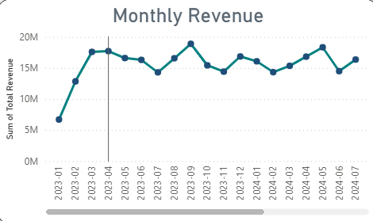

- Revenue by City – Bar Chart
Chennai and Bengaluru contribute the highest share of total revenue, while Delhi generates comparatively lower revenue. This indicates stronger market performance in southern branches.

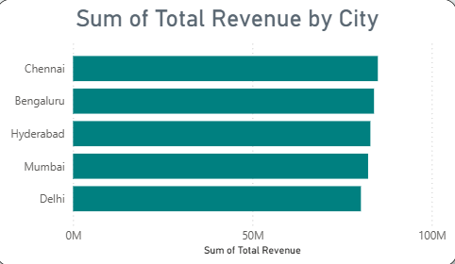

- Revenue Performance vs Target – Gauge Chart
The total revenue of 414.29M significantly exceeds the benchmark target of 180M, indicating strong financial performance and effective revenue strategy.

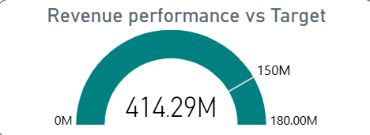

- Room Type – Donut Chart
Revenue contribution is almost evenly distributed across Suite, Executive, Deluxe, and Standard rooms, showing balanced pricing and demand across categories.

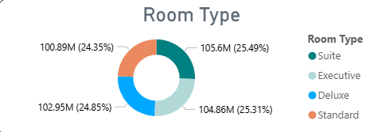

Module 2: Occupancy & Revenue Metrics
Module Description
The Booking Channel and Segment Analysis module evaluates revenue contribution across different booking sources and customer segments. It helps identify which channels generate maximum revenue and how different customer groups impact overall performance. The module also analyzes revenue by stay duration to understand booking behaviour patterns. These insights support channel optimization and targeted marketing strategies.
Key Metrics
ADR = DIVIDE ([Total Revenue], [Rooms Sold])
Total Revenue = SUM (Fact_Hotel_Revenue [Total Revenue])
Maximum Revenue = [Target Revenue] * 1.2

Charts & Insights
- Revenue by Booking Channel – Bar Chart
Revenue generation is consistently strong across OTA, Travel Agent, Corporate, and Direct channels. OTA and Travel Agent channels slightly outperform others, indicating dependency on third-party distribution platforms.
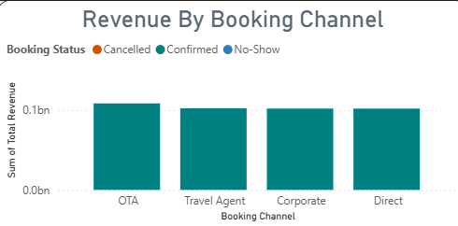

- Segment-wise Revenue Contribution – Tree Map
Revenue is fairly distributed across customer segments, with no single segment dominating completely. This reflects a diversified customer base and stable revenue streams.

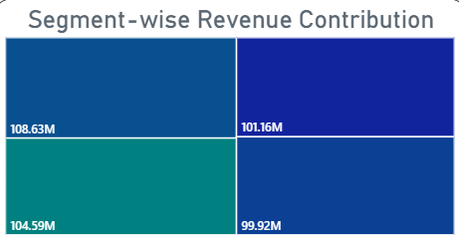

- Revenue by Stay Duration – Funnel Chart
Longer stay durations contribute significantly higher revenue compared to short stays. This suggests that extended bookings positively impact profitability.
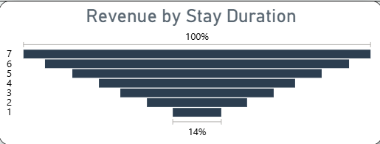

- Revenue Distribution by Channel – Donut Chart
Revenue share across booking channels is nearly balanced (~24–26% each), indicating healthy multi-channel distribution without over-reliance on a single source.
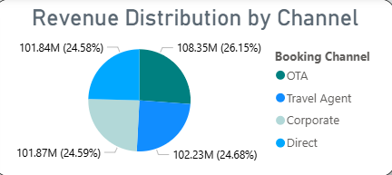

Module 3: Guest Analysis Module
Module Description
The Guest Demographics and Loyalty Analysis module evaluates customer profiles based on nationality, age group, guest type, and loyalty status. It provides insights into the composition of the hotel’s customer base and identifies high-value customer segments. The module also analyzes the revenue contribution of loyal customers to assess retention effectiveness. These insights support personalized marketing, customer targeting, and long-term relationship strategies.
Key Metrics
Loyal Revenue = CALCULATE ([Total Revenue], Fact_Hotel Revenue [Loyal Customer] = "Yes")

Charts & Insights
- Guest Nationality – Map Visualization
Bookings are distributed across multiple continents including North America, Europe, Asia, and Australia, indicating international customer reach and global brand presence.
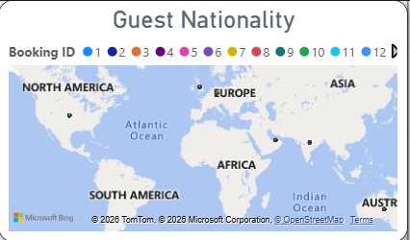

- Loyal Customer – Line Chart
Revenue and booking trends show a steady contribution from loyal customers, closely matching non-loyal bookings. This suggests consistent repeat customer engagement.
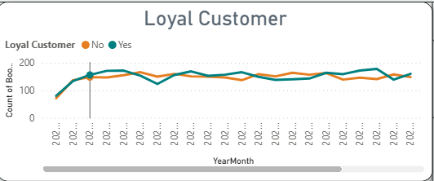

- Guest Type Distribution – Donut Chart
Family, Solo, Business, and Couple segments contribute almost equally (~24–25% each), indicating balanced demand across guest categories.

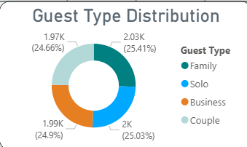

- Age Group Analysis – Bar Chart
The 46–60 and 26–35 age groups show higher booking volumes, highlighting strong engagement from middle-aged and working professionals.
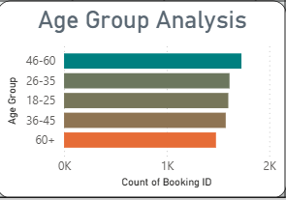

- Stay Duration vs Profit – Scatter Plot
Longer stay durations generally correspond with higher profit contribution, especially for family and solo segments.
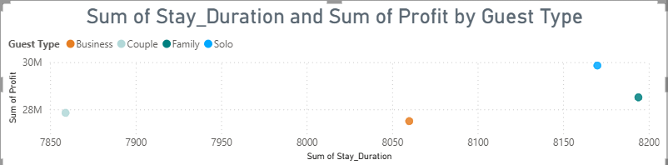

Module 4: Forecasting and Cancellation Trends

Module Description
The Cancellation and Booking Risk Analysis module evaluates booking cancellations, trends, and risk patterns across guest types and booking channels. It helps identify cancellation behaviour over time and measures the impact on overall revenue performance. The module provides daily cancellation rate tracking and comparative analysis among customer segments. These insights support better forecasting, overbooking strategies, and risk mitigation planning.
Key Metrics
Cancelled Bookings = CALCULATE (
[Total Bookings],
Fact_Hotel_Revenue [Cancellation Flag] = 1
)
Cancellation Rate = DIVIDE ([Cancelled Bookings], [Total Bookings])

Charts & Insights
- Cancellation Rate by Day – Line Chart
The daily cancellation rate fluctuates between approximately 15%–22%, with noticeable spikes toward later days. The shaded forecast region indicates predicted variability in cancellation behaviour.
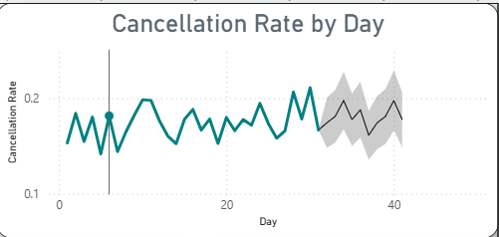

- Cancellation Trend – Gauge Chart
Total cancelled bookings (1392) represent a significant portion of overall bookings, highlighting the need for active cancellation management strategies.

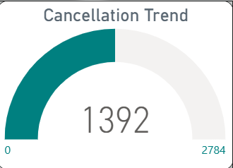

- Cancellation by Guest Type – Bar Chart
Business and Family segments show slightly higher cancellation counts compared to Couple and Solo travellers, suggesting corporate and group-related booking volatility.
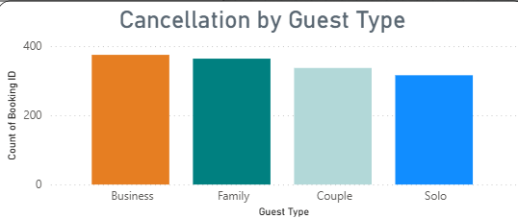

- Booking Channel Distribution – Donut Chart
Cancellation impact is distributed across OTA, Direct, Travel Agent, and Corporate channels, indicating that no single channel dominates cancellation risk.
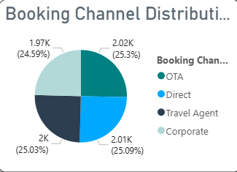

- Cancellation Rate Breakdown – Decomposition Visual
Family and Business segments show cancellation rates around 17–19%, helping management identify higher-risk customer groups.
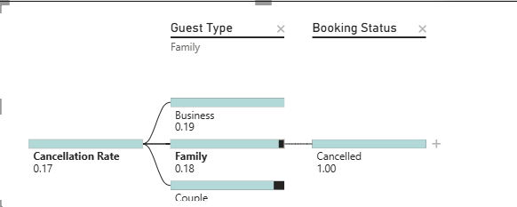

Module 5: Revenue Strategy Dashboard

Module Description
The Strategic Revenue and Forecasting module provides advanced insights into profitability trends, revenue targets, and future performance projections. It analyzes cumulative profit patterns, property-wise profitability, and geographical contribution to overall earnings. The module also integrates revenue forecasting to support long-term planning and pricing strategy decisions. This dashboard serves as a decision-support system for executives and revenue managers.
Key Metrics
Upsell Index =
SUMX (
Booking_Fact,
Booking_Fact [Total_Revenue] * Booking_Fact [Nights]
)

Charts & Insights
- Cumulative Monthly Profit Trend – Area Chart
Profit shows a gradual decline across months, indicating possible seasonal slowdown or increased operational costs in later periods.
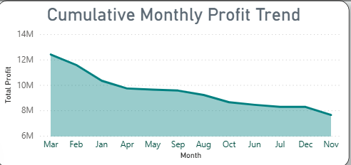

- Revenue Forecast – Line with Confidence Interval
The forecast predicts stable revenue with slight variability toward future years. The confidence band highlights uncertainty but indicates controlled revenue fluctuations.
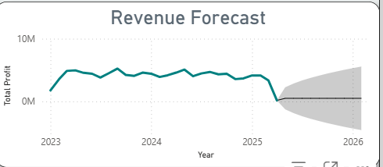

- Strategic Revenue Target – Gauge Chart
Total revenue of 414.29M significantly exceeds the benchmark target of 150M, reflecting strong strategic performance.
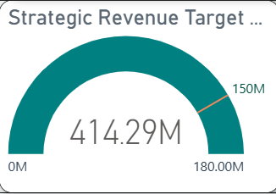

- Property-Wise Profitability – TreeMap
Hotel Grand Vista and Hotel Aurora contribute the largest share of total profit, identifying high-performing properties.
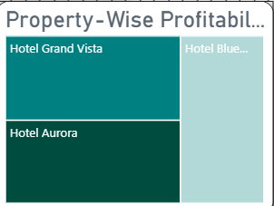

- Geographical Profit Breakdown – Waterfall Chart
Cities like Chennai, Bengaluru, and Hyderabad contribute incremental profit increases, showing strong regional revenue growth.
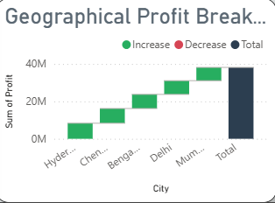

Architecture Diagram

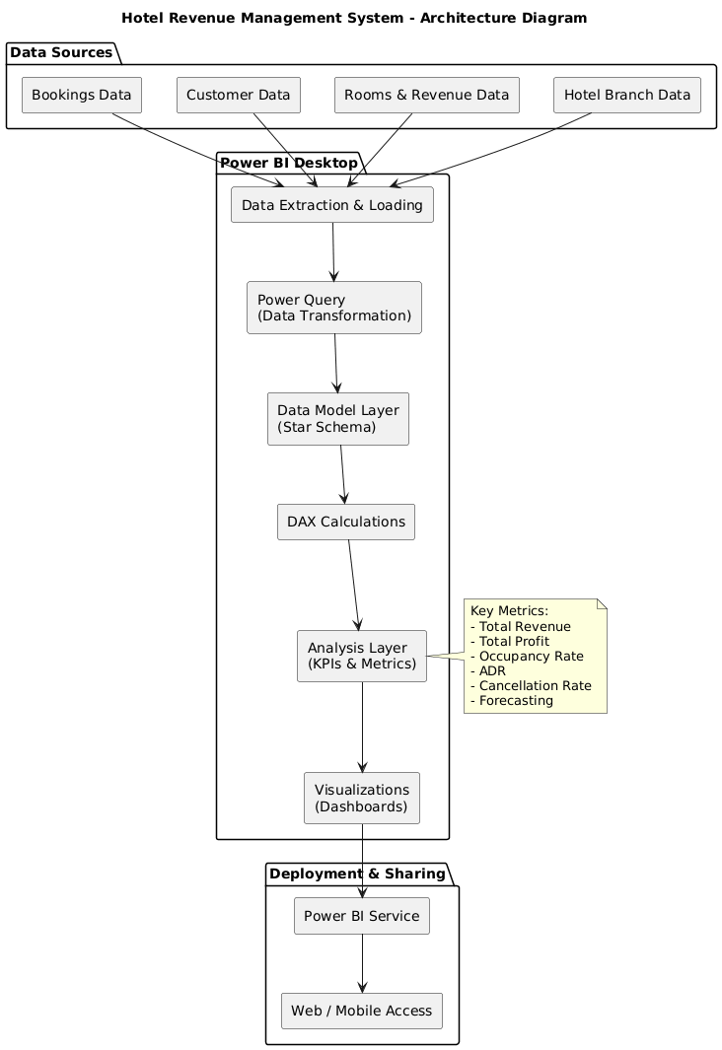

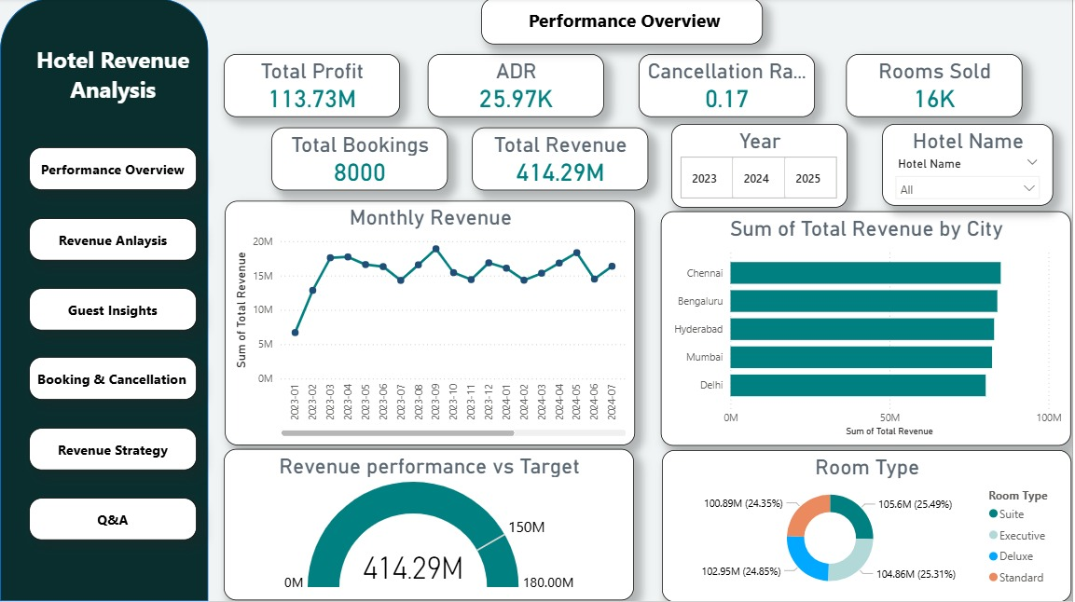
Snippets of Dashboard

Fig Performance Overview
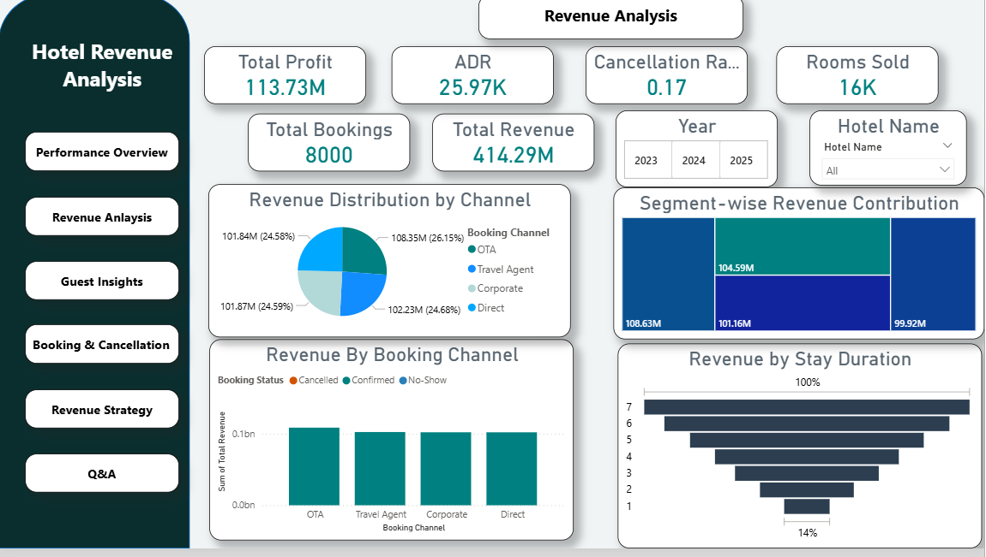
Fig Revenue Analysis

Fig Guest Analysis & Insights

Fig Booking & Cancellation Analysis
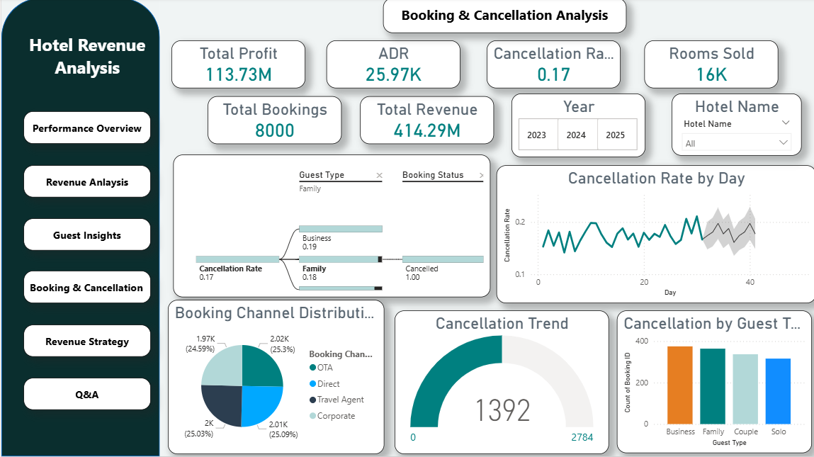
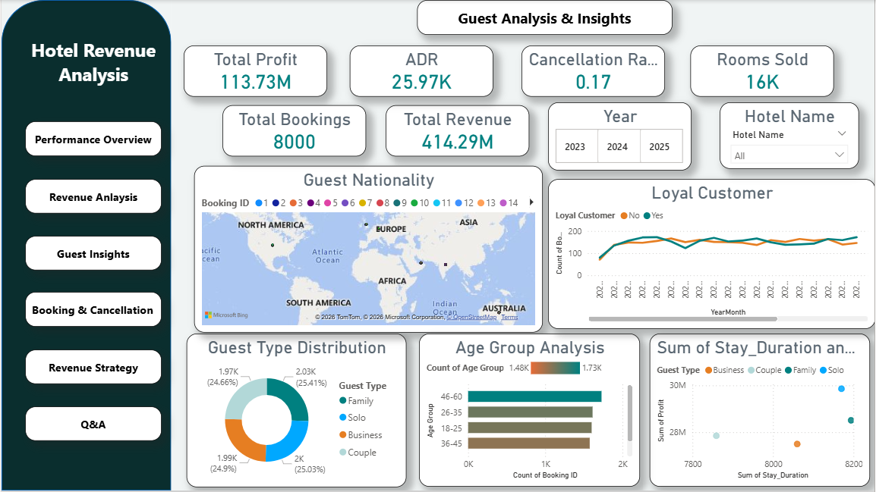

Fig Revenue Strategy

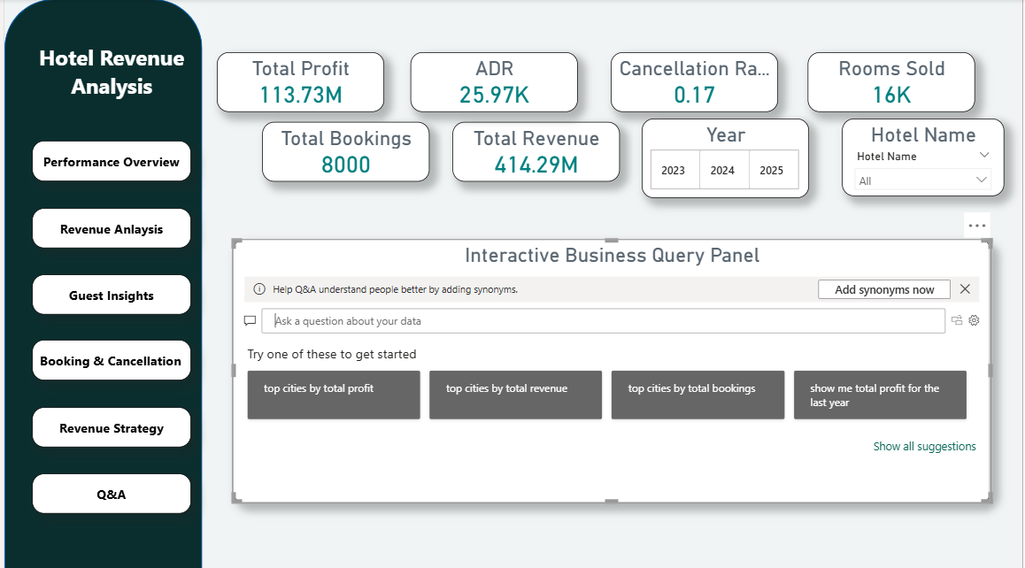
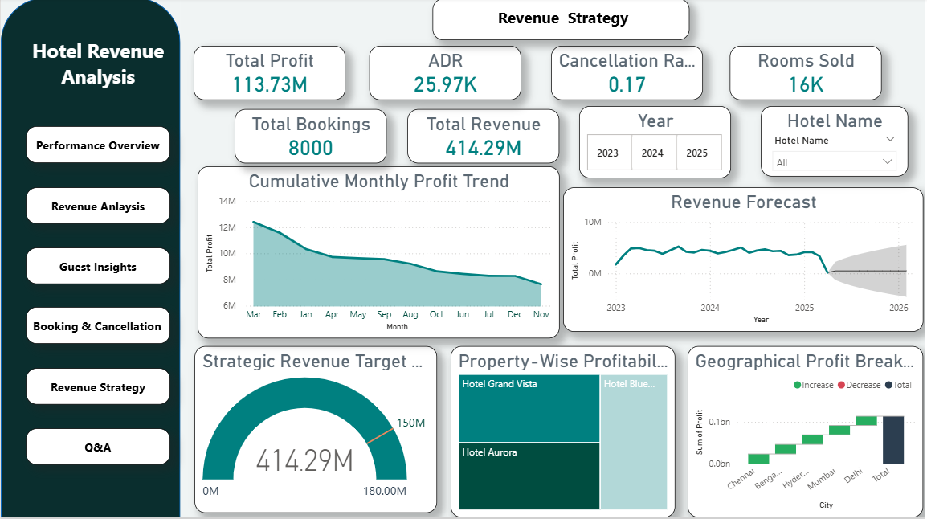
Fig Question/Answer

Conclusion

The Hotel Revenue Management dashboard successfully demonstrates how business intelligence can be leveraged to improve decision-making in the hospitality industry. By integrating booking, customer, and revenue data into a structured Power BI model, the system provides clear visibility into occupancy trends, revenue performance, guest behaviour, and cancellation patterns. Key metrics such as Total Revenue, ADR, Profit, and Cancellation Rate enabled performance monitoring at both branch and segment levels. The forecasting and strategic analysis modules further supported proactive planning and revenue optimization. Overall, the project highlights the effectiveness of data modelling, DAX calculations, and interactive visualizations in transforming raw hotel data into actionable business insights.

Future Enhancements

- Implement advanced machine learning models for more accurate revenue and occupancy forecasting.
- Integrate real-time data from booking engines and hotel management systems.
- Develop dynamic pricing recommendations based on demand patterns and competitor analysis.
- Incorporate sentiment analysis from guest reviews to enhance service quality insights.
- Build automated alert systems for high cancellation rates or revenue drops.
- Expand the model to include multiple hotel chains and international branches.

